CS4475 Fall 2026 Lab Report #2
Luis Arturo Carreon Submitted on October 14th 2026
lacarreon@miners.utep.edu

PA2: Priority-based Scheduler for xv6

Task 1. (15 pts) Implement the getprocs() system call and test it using the provided ps command.
The getprocs() function iterates through the xv6 process table using a loop. For each process, it acquires the corresponding process lock and checks whether the process is currently in use. If the process is active, its information is copied into a pstat structure, including its PID, state, memory size, parent PID, and name. The copyout() function is then used to transfer this information from kernel space to the user-space buffer provided by the calling process. After copying the information, the process lock is released, and a counter is incremented to keep track of the number of processes retrieved. The function then returns the total number of processes found.
First I modified and placed the pstat.h file that we will use, by itself it gave an error and needed consistent debugging and restructuring to work as required.
Then we added `getprocs()` on the user interface, we declared `struct pstat` on the user.h header so that we allow user-space programs to reference the structure and call the new system calluser space, then on the xv6’s systemcall prototypes we added it, very similar to how it was done in PA1.
After that, we added it on the usys.pl file so as to allow the user to call it alongside other systemcalls like fork, exit or wait.
On syscall.h we assigned “getprocs()” a syscall number, in our case, it was ‘24’.
On syscall.c, we connected it to the sycall dispatcher, alongside other systemcalls, declaring it both at the declarations at the top and in the syscall table.
Then we proceeded to implement it on the kernel side, In kernel/sysproc.c, we implemented the sys_getprocs() system call handler, which retrieves the user-space address passed to the system call and invokes the kernel’s getprocs() function, on sysproc.c we also added/included pstat.h and declared its function at the bottom.
We also declared it as a kernel function in defs.h.
Later, we implement the actual `getprocs()` program in proc.c, including pstat.h, at the bottom we added our full getprocs function.
Finally we added the ‘ps’ command to the Makefile (UPROGS) and the xv6 directory, after that we recompiled qemu and xv6 while debugging the new files so that it works correctly, since I wanted to keep the PA1 commands working alongside the new ones.
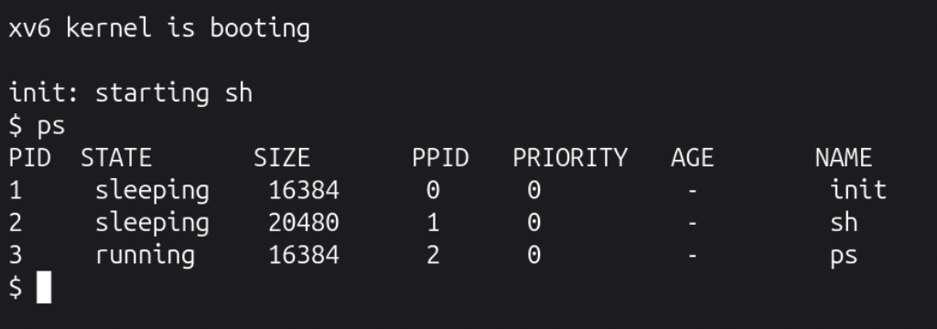
(The output of the ‘ps’ command on xv6, note that at this point we have also implemented task 1 and 3, so it also shows the priority and age of the process)

Task 2. (15 pts) Modify the provided ps command to print the priority of each process.
First we modified `struct proc` in “proc.h”, specifically we added a new integer variable called priority (from 0 (max) to 49 (min).
On the kernel proc.c, we initialized the priority of newly allocated processes (one for each one that it is called), this ensures that all new processes have a valid priority value when they are created, often at priority 0.
Then, on pstat.h from the kernel, we added “priority” to the struct pstat, so that when we use the ‘ps’ commande we can also observe the priority of a process alongside other information such as those shown in the screenshot.
We then updated the getprocs() function in the kernel’s `proc.c` to also retrieve the priority of each active process, we copy the priority from the kernel’s process structure into the pstat structure, and is then transferred to the user mode using copyout().
Finally we modified the `ps.c` file so that it displays the priority of each process correctly by adding a new column.

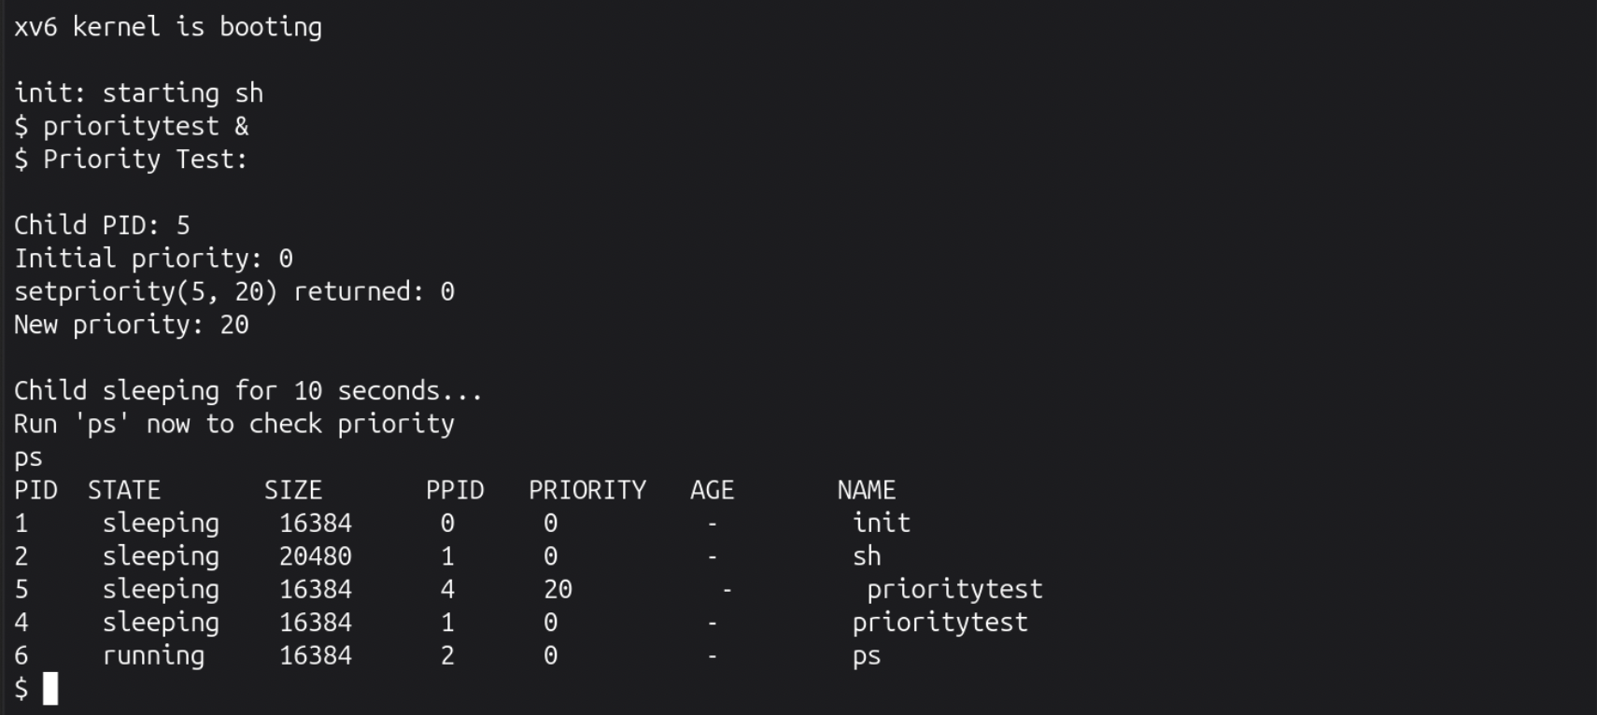
(The output of the ‘ps’ command while also running the priority test program, we can see how we set the priority of a program to 20, while the rest of the programs have that of 0)

Task 3. (15 pts) Add a readytime field to struct proc, initialize it correctly, and modify ps to print a process’s age.
In the kernel’s proc.h we added `uint readytime` to struct proct to store when the process became runnable.
In proc.c, we initialized and updated readytime whenever a process entered the RUNNABLE state, for a total of 5 times, we also modified `getprocs()` to copy this value.
In pstat.h we also added `uint readytime` to struct pstat so that the information copied can be transferred to the user space.
Finally in user/ps.c, we added the age column and implemented the age calculation using uptime().
We calculated the process’s age by subtracting the time when it became runnable from the current system uptime: Age = Current Time – Ready Time, both measured in xv6 ticks.
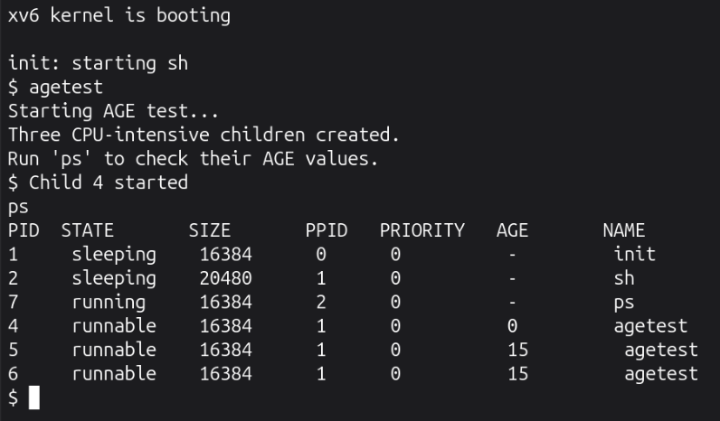
(The results of running the ‘agetest’ program, it allows us to see the age of the processes)

Task 4. (15 pts) Implement a priority-based scheduler.
On the kernel’s `param.h` I added some constant that allow us to select between the standard xv6 Round-Robin policy and the new Priority-Based scheduling.
On `proc.c we modified the majority of the `scheduler()` so that it would behave according to the selected policy and implemented the changes so that it selects the highest-priority runnable process when using that policy.
In `proc.h` we refined the priority field from the previous tasks
Modified `pexec.c` so that it works with my implemented policy, finally we added it in Makefile.
From this task I learned the different behaviors that dictate the scheduling policy of either RR or Priority scheduling, the benefits and downsides of each and all the required changes to xv6 to implement a priority scheduler.
The main difficulty was making sure that my implementation worked correctly with the xv6 architecture, requiring debugging and constant modification so that we could compile correctly.

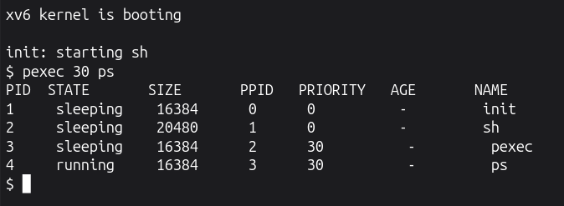
(The results of running the `pexec` command while setting the priority to 30)

Task 5. (15 pts) Add aging to your priority-based scheduler.
My policy is a simple linear priority aging, but with a fair tie breaking to avoid starving at the maximum, that is, if two processes have the same effective priority, the scheduler selects the one that has waited for longer.
In `proc.c` I modified the scheduler() to implement priority aging.
In param.h I added the scheduling policy, aging interval and maximum priority definitions.
Beyond that I created a couple testing programs and added them to makefile.
From this task I learned how aging works in computer schedulers, their limitations and ways to remediate their shortfalls such as starvation and stagnation if too many processes rach max age, my main difficulties where with debugging and in implementing a program that showcases aging working as expected.
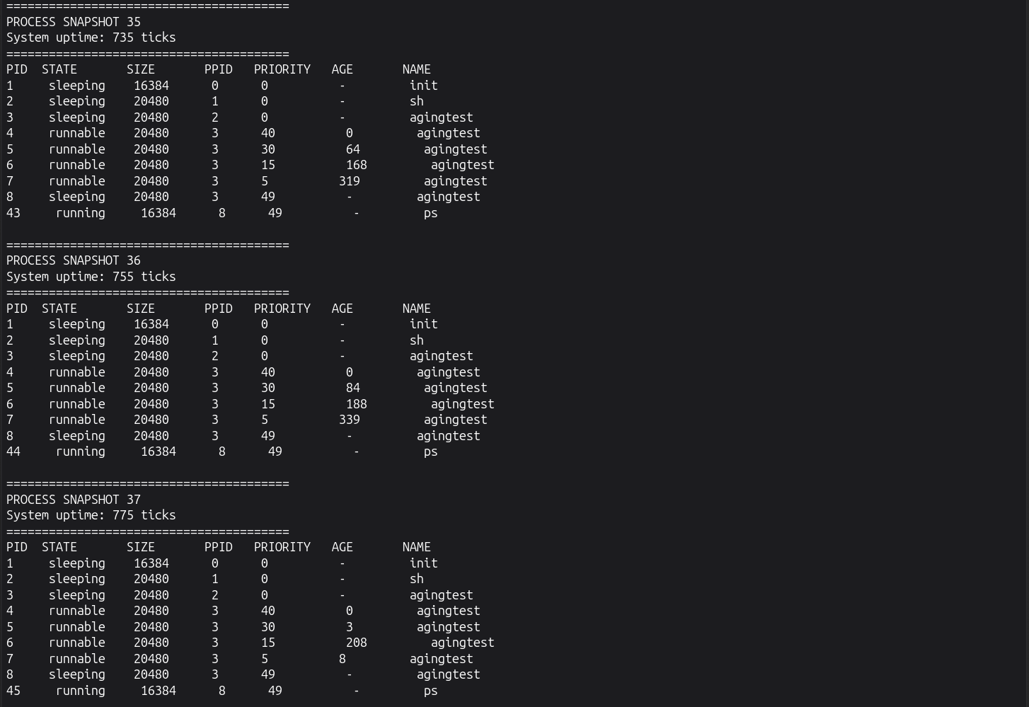
(A few snapshots from the agingtest program, we can see how some processes age and deage as they are used by the cpu and abandoned respectively)

Task 6. (5 pts) Summary
This assignment helped me familiarize myself with how operating systems manage process and allocate them time in the CPU, the different algorithms and differences between them, shortfalls and advantages; my main obstacles where making sure the implementation of the new priority scheduler and aging worked successfully, especially showing that it worked as intended with intensive processes since most of my test were too small or short and thus aging would not even kick in for a single process.

Extra Credit Task (10 points).
In proc.h, I added the priority field to the process structure.
In proc.c I added the process priority management and incorporated priorities into scheduling decisions.
In sysproc.c, I added the systemcall handlers for `getpriority()` and `setpriority()`
In defs.h, I added the kernel function declarations
In syscall.h, I assigned system call numbers to both of them
In syscall.c, I registered both system calls in the system call dispatch table
In user.h, I declared the user-space system call interfaces
In usys.pl, I added entries to generate the user space system call wrappers.
Beyond these I added some testing programs, and those in turn were added to the makefile.
These commands can improve response times as setting a higher priority in the new priority scheduler will make it more likely for the CPU to pick it for its assorted time.

(Here we cab see how processes with higher priority have less age as result of the scheduler giving them more time in the CPU unlike processes with low priority like 5 which have aged significantly since there its competing with processes with higher priorities)

